SCHOOL OF COMPUTER SCIENCE AND ARTIFICIAL INTELLIGENCE |  |  |  |  | DEPARTMENT OF COMPUTER SCIENCE ENGINEERING
ProgramName:MCA |  |  |  | Assignment Type: Lab |  |  | AcademicYear:2025-2026
CourseCoordinatorName |  |  |  | Venkataramana Veeramsetty
CourseCode |  |  |  | CourseTitle |  | AI Assisted Problem Solving Using Python
Year/Sem |  |  | II/I | Regulation |  | R24
Date and Day  of Assignment |  |  | 10.11.2025 | Time(s)
Duration |  |  | 2 Hours | Applicableto  Batches
AssignmentNumber:8.3(Present assignment number)/24(Total number of assignments)
 | Q.No. | Question |  |  |  |  |  | ExpectedTime  to complete
 | 1 | Lab 8: Test-Driven Development with AI – Generating and Working with Test Cases  Lab Objectives:  - To introduce students to test-driven development (TDD) using AI code generation tools.  - To enable the generation of test cases before writing code implementations.  - To reinforce the importance of testing, validation, and error handling.  - To encourage writing clean and reliable code based on AI-generated test expectations.  Lab Outcomes (LOs):  After completing this lab, students will be able to:  - Use AI tools to write test cases for Python functions and classes.  - Implement functions based on test cases in a test-first development style.  - Use unittest or pytest to validate code correctness.  - Analyze the completeness and coverage of AI-generated tests.  - Compare AI-generated and manually written test cases for quality and logic  Task Description#1  Use AI to generate test cases for is_valid_email(email) and then implement the validator function.  Requirements:  - Must contain @ and . characters.  - Must not start or end with special characters.  - Should not allow multiple @.  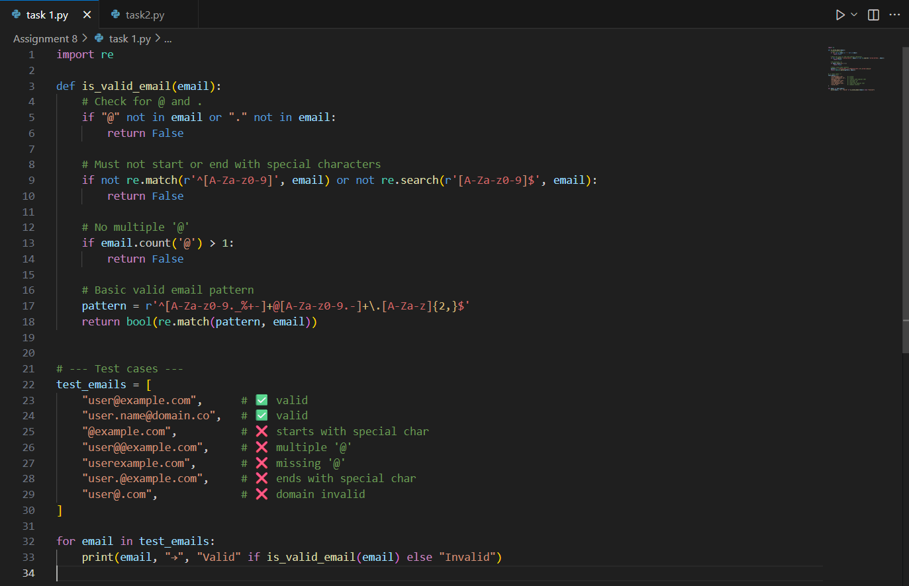  Expected Output#1  - Email validation logic passing all test cases  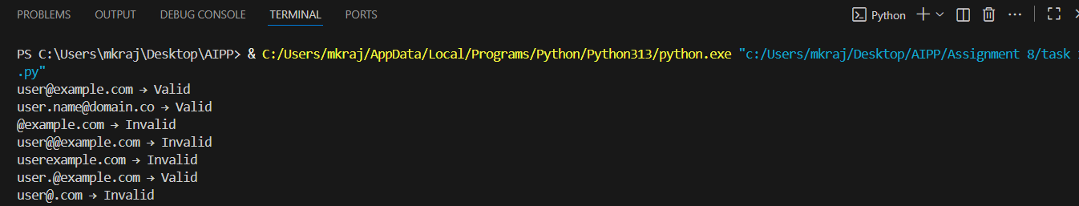  Task Description#2 (Loops)  - Ask AI to generate test cases for assign_grade(score) function. Handle boundary and invalid inputs.  Requirements  - AI should generate test cases for assign_grade(score) where: 90-100: A, 80-89: B, 70-79: C, 60-69: D, <60: F  - Include boundary values and invalid inputs (e.g., -5, 105, "eighty").  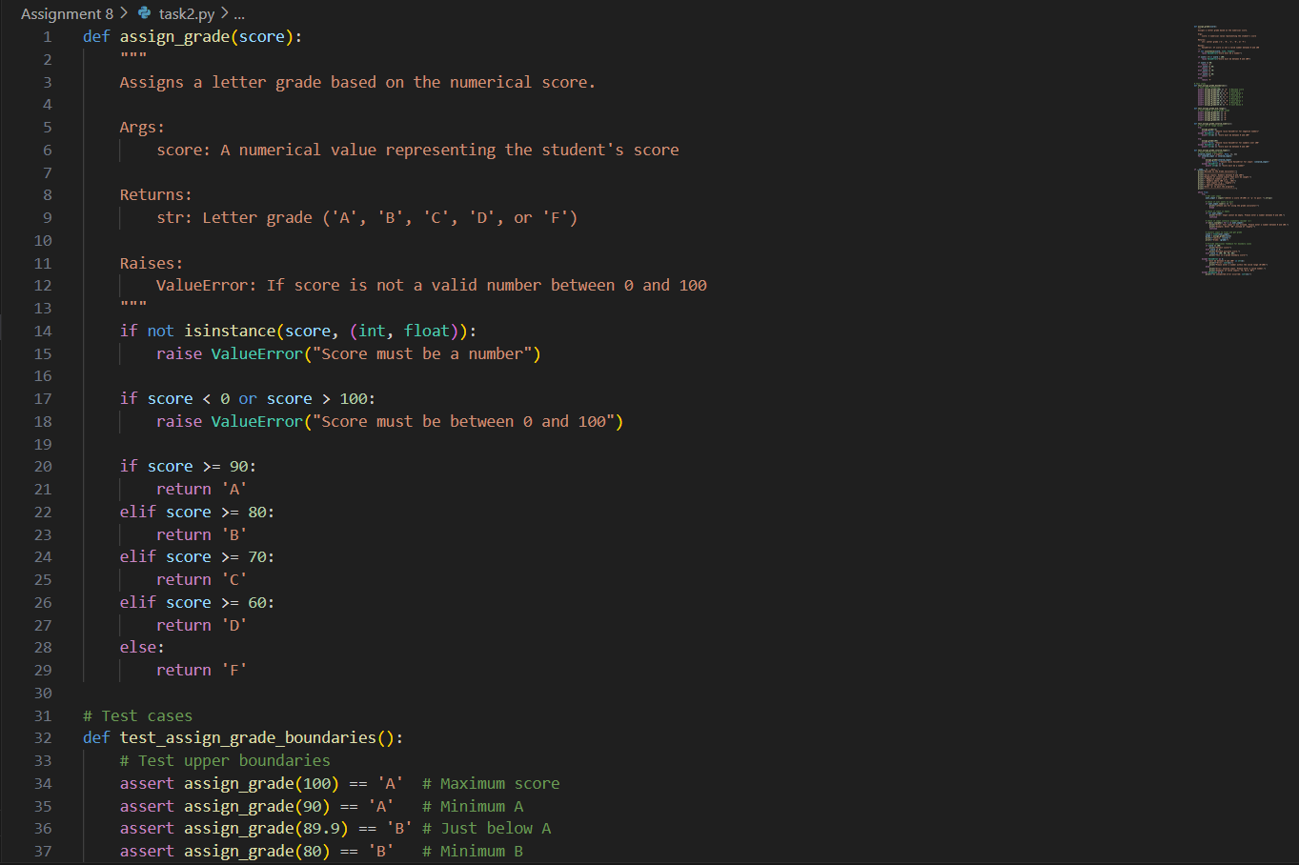  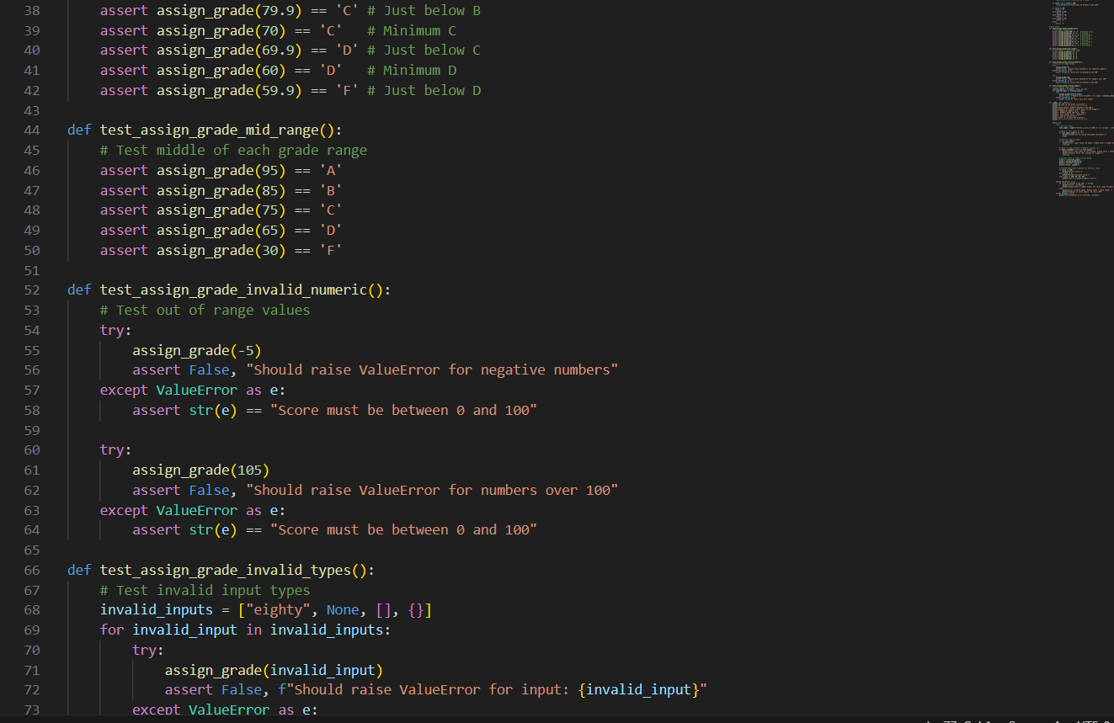  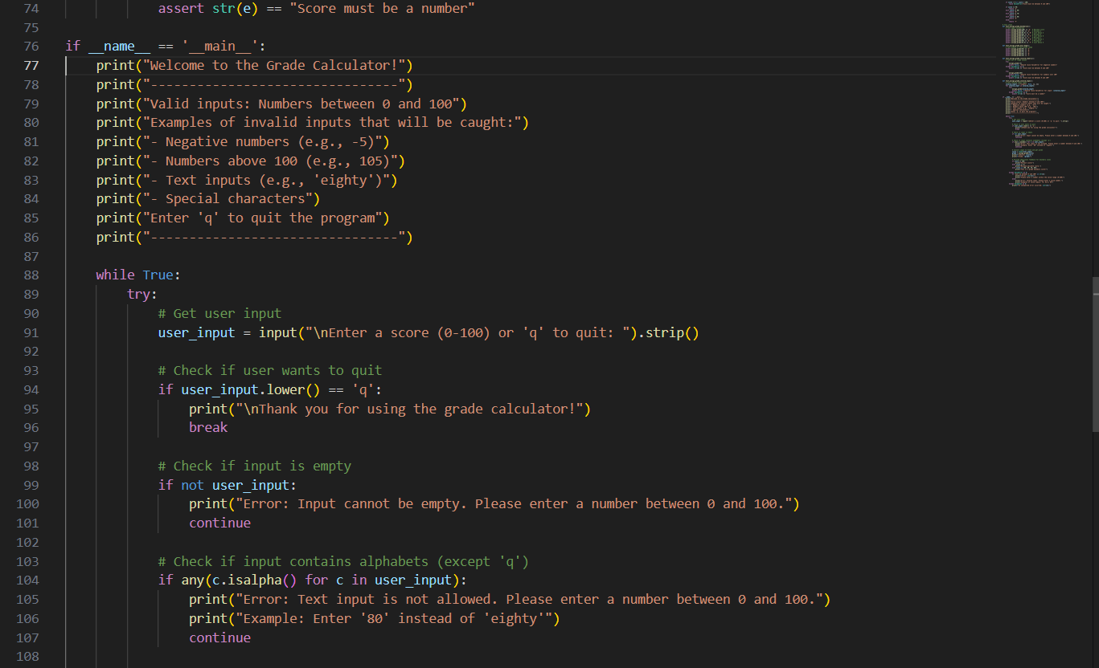  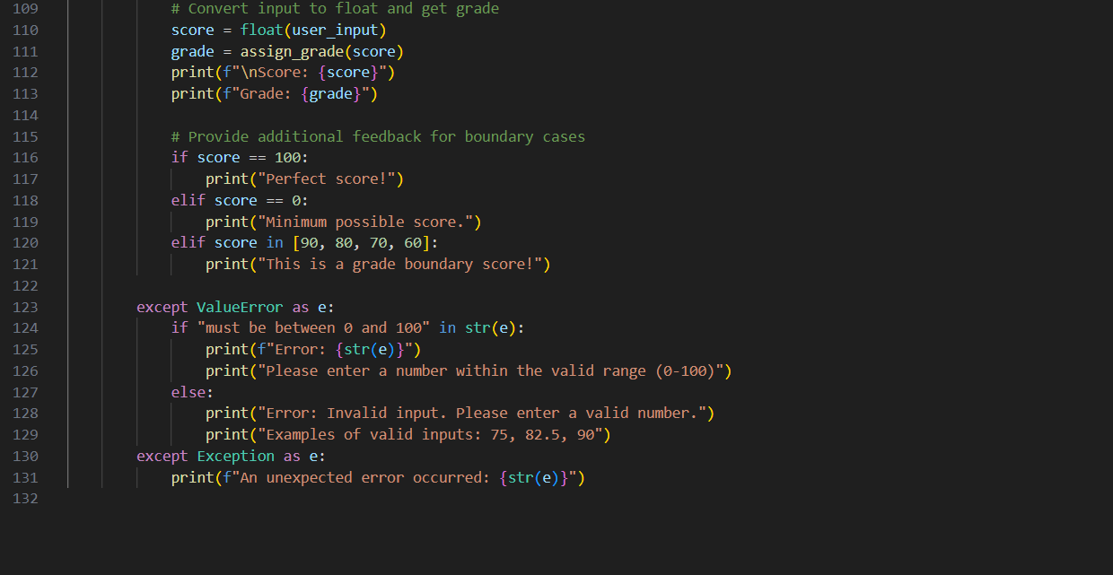  Expected Output#2  Grade assignment function passing test suite  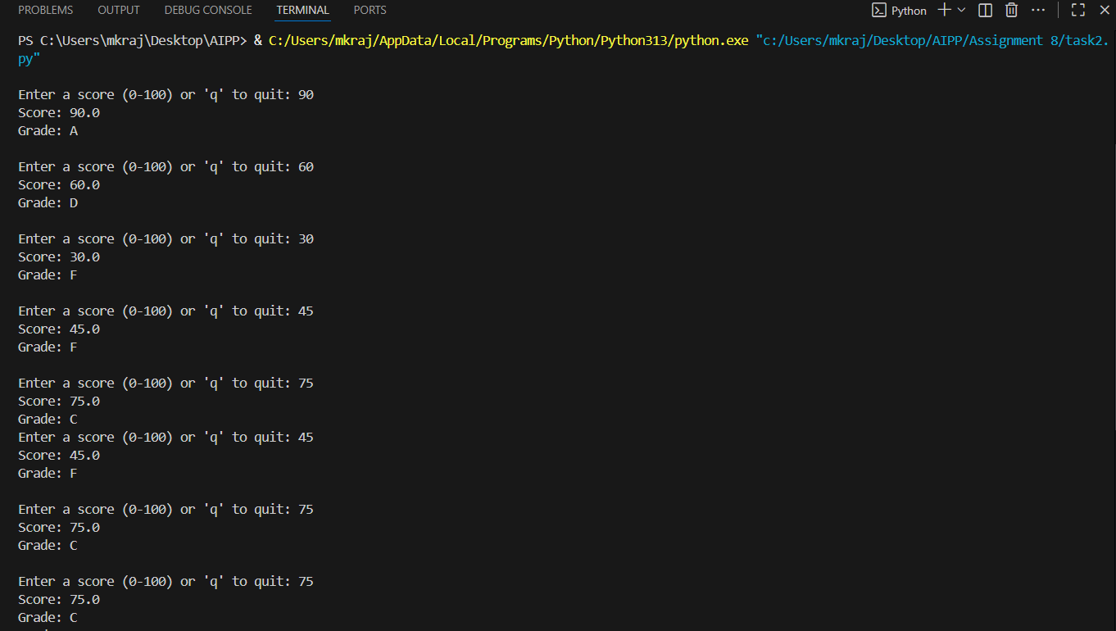  Task Description#3  - Generate test cases using AI for is_sentence_palindrome(sentence). Ignore case, punctuation, and spaces  Requirement  - Ask AI to create test cases for is_sentence_palindrome(sentence)  (ignores case, spaces, and punctuation).  - Example:  "A man a plan a canal Panama" → True  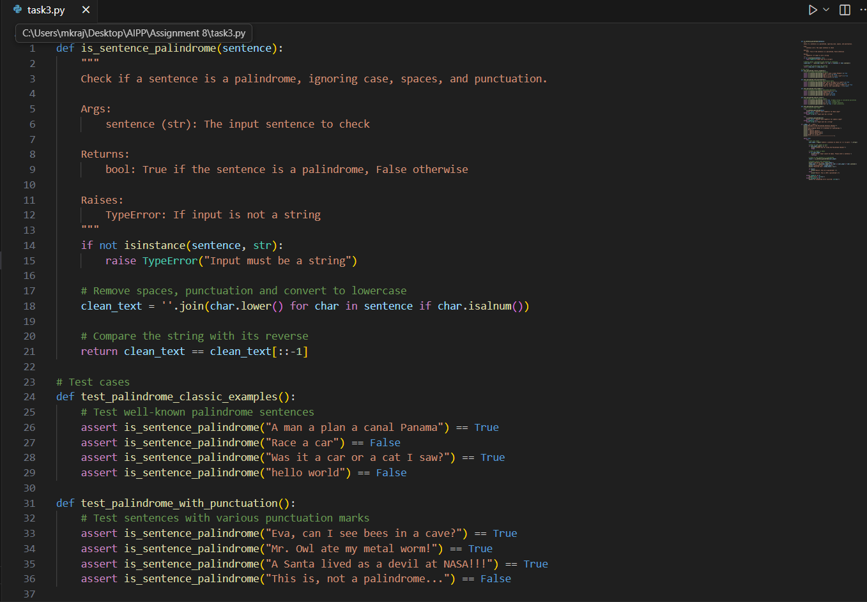  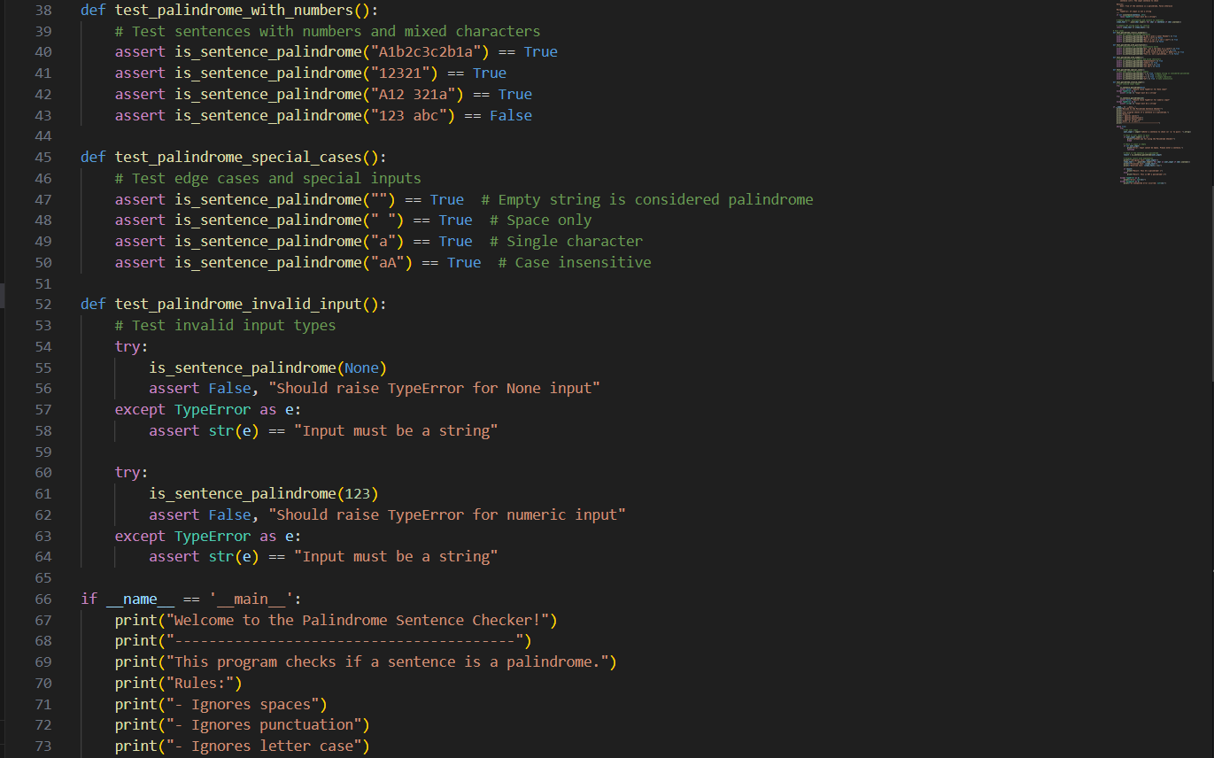  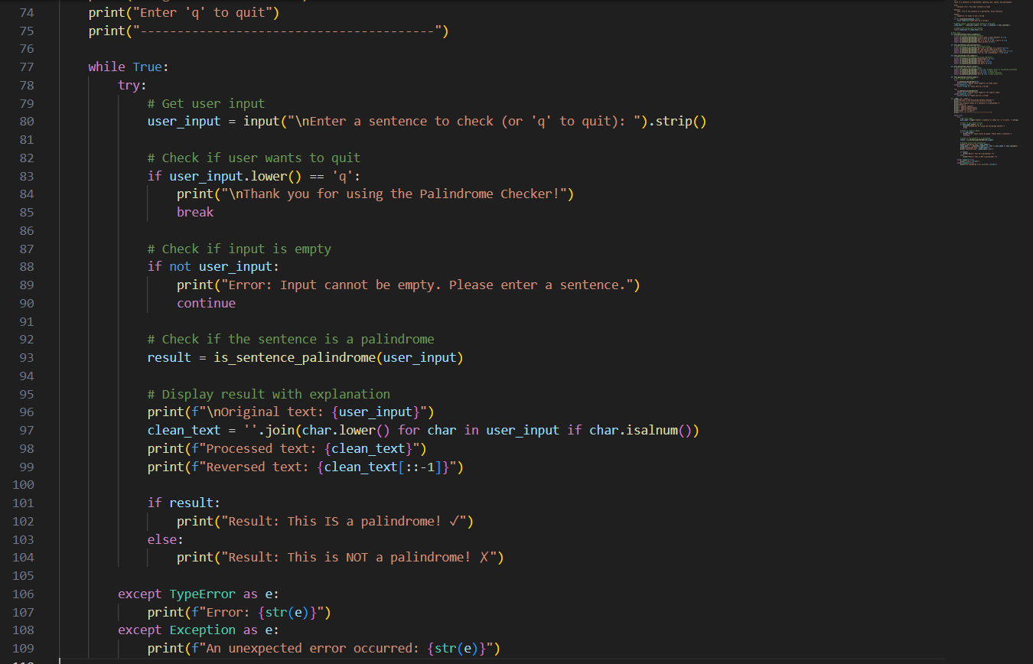  Expected Output#3  - Function returns True/False for cleaned sentences  - Implement the function to pass AI-generated tests.  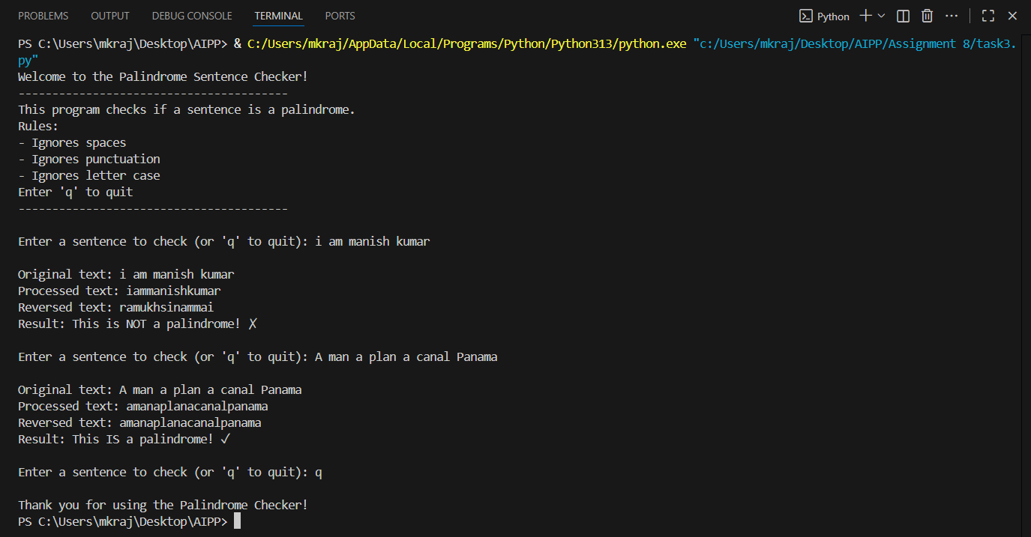  Task Description#4  - Let AI fix it Prompt AI to generate test cases for a ShoppingCart class (add_item, remove_item, total_cost).  Methods:  Add_item(name,orice)  Remove_item(name)  Total_cost()  Code  class ShoppingCart:  """  A class to manage a shopping cart with items and their prices.  """  def __init__(self):  """Initialize an empty shopping cart"""  self.items = {} # Dictionary to store items with their prices  def add_item(self, name, price):  """  Add an item to the shopping cart  Args:  name (str): The name of the item  price (float): The price of the item  Raises:  ValueError: If price is negative or name is empty  TypeError: If name is not string or price is not a number  """  # Validate input types  if not isinstance(name, str):  raise TypeError("Item name must be a string")  if not isinstance(price, (int, float)):  raise TypeError("Price must be a number")  # Validate input values  if not name.strip():  raise ValueError("Item name cannot be empty")  if price < 0:  raise ValueError("Price cannot be negative")  # Add or update item in cart  self.items[name.lower()] = price  def remove_item(self, name):  """  Remove an item from the shopping cart  Args:  name (str): The name of the item to remove  Raises:  ValueError: If item is not in cart  TypeError: If name is not a string  """  if not isinstance(name, str):  raise TypeError("Item name must be a string")  name = name.lower()  if name not in self.items:  raise ValueError(f"Item '{name}' not found in cart")  del self.items[name]  def total_cost(self):  """  Calculate the total cost of all items in the cart  Returns:  float: The total cost of all items  """  return sum(self.items.values())  # Test cases  def test_add_item_basic():  cart = ShoppingCart()  # Test adding single item  cart.add_item("Apple", 0.50)  assert cart.items["apple"] == 0.50  # Test adding multiple items  cart.add_item("Banana", 0.75)  cart.add_item("Orange", 0.60)  assert len(cart.items) == 3  assert cart.items["banana"] == 0.75  def test_add_item_case_insensitive():  cart = ShoppingCart()  # Test case insensitivity  cart.add_item("Apple", 0.50)  cart.add_item("aPPle", 0.60) # Should update the price  assert len(cart.items) == 1  assert cart.items["apple"] == 0.60  def test_add_item_invalid_input():  cart = ShoppingCart()  # Test invalid price types  try:  cart.add_item("Apple", "0.50")  assert False, "Should raise TypeError for string price"  except TypeError as e:  assert str(e) == "Price must be a number"  # Test invalid name types  try:  cart.add_item(123, 0.50)  assert False, "Should raise TypeError for numeric name"  except TypeError as e:  assert str(e) == "Item name must be a string"  # Test empty name  try:  cart.add_item("", 0.50)  assert False, "Should raise ValueError for empty name"  except ValueError as e:  assert str(e) == "Item name cannot be empty"  # Test negative price  try:  cart.add_item("Apple", -0.50)  assert False, "Should raise ValueError for negative price"  except ValueError as e:  assert str(e) == "Price cannot be negative"  def test_remove_item():  cart = ShoppingCart()  # Add and remove item  cart.add_item("Apple", 0.50)  cart.remove_item("Apple")  assert len(cart.items) == 0  # Test case insensitivity in removal  cart.add_item("Banana", 0.75)  cart.remove_item("BANANA")  assert len(cart.items) == 0  # Test removing non-existent item  try:  cart.remove_item("Orange")  assert False, "Should raise ValueError for non-existent item"  except ValueError as e:  assert str(e) == "Item 'orange' not found in cart"  def test_total_cost():  cart = ShoppingCart()  # Test empty cart  assert cart.total_cost() == 0  # Test with one item  cart.add_item("Apple", 0.50)  assert cart.total_cost() == 0.50  # Test with multiple items  cart.add_item("Banana", 0.75)  cart.add_item("Orange", 0.60)  assert cart.total_cost() == 1.85  # Test after removing item  cart.remove_item("Apple")  assert cart.total_cost() == 1.35  if __name__ == '__main__':  print("Welcome to the Shopping Cart System!")  print("-----------------------------------")  print("Available commands:")  print("1. add item_name price")  print("2. remove item_name")  print("3. total")  print("4. quit")  print("-----------------------------------")  cart = ShoppingCart()  while True:  try:  command = input("\nEnter command: ").strip().lower()  if command == 'quit':  print("\nThank you for using the Shopping Cart System!")  break  elif command == 'total':  total = cart.total_cost()  print(f"Total cost: ${total:.2f}")  elif command.startswith('add '):  # Parse add command: "add item_name price"  parts = command.split()  if len(parts) < 3:  print("Error: Please provide both item name and price")  continue  name = ' '.join(parts[1:-1]) # Join multi-word item names  price = float(parts[-1])  cart.add_item(name, price)  print(f"Added '{name}' at ${price:.2f}")  elif command.startswith('remove '):  # Parse remove command: "remove item_name"  name = command[7:].strip()  cart.remove_item(name)  print(f"Removed '{name}' from cart")  else:  print("Invalid command. Please try again.")  except ValueError as e:  print(f"Error: {str(e)}")  except TypeError as e:  print(f"Error: {str(e)}")  except Exception as e:  print(f"An unexpected error occurred: {str(e)}")  Expected Output#4  - Full class with tested functionalities  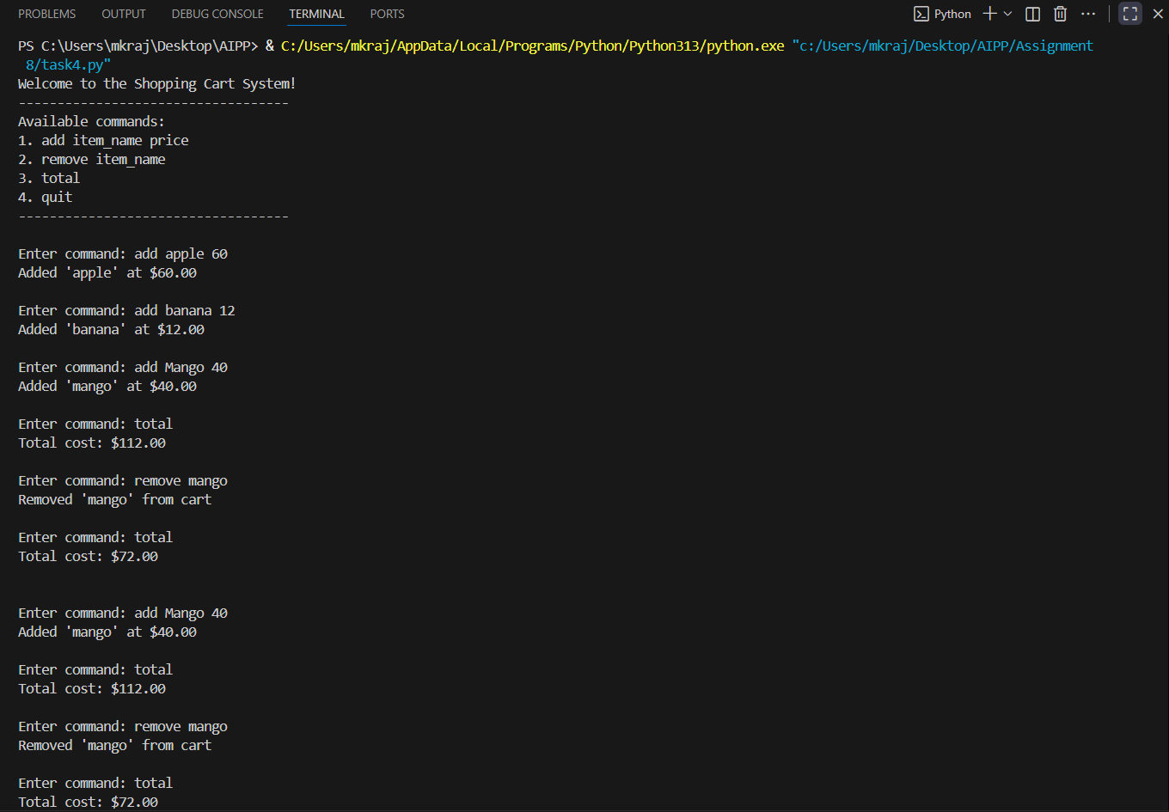  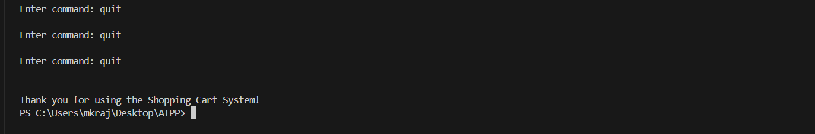  Task Description#5  - Use AI to write test cases for convert_date_format(date_str) to switch from "YYYY-MM-DD" to "DD-MM-YYYY".  Example: "2023-10-15" → "15-10-2023"  Code  def convert_date_format(date_str):  """  Converts a date string from 'YYYY-MM-DD' to 'DD-MM-YYYY' format.  Args:  date_str (str): Date string in 'YYYY-MM-DD' format  Returns:  str: Date string in 'DD-MM-YYYY' format  Raises:  ValueError: If input is not a valid date string  """  if not isinstance(date_str, str):  raise ValueError("Input must be a string")  parts = date_str.split('-')  if len(parts) != 3:  raise ValueError("Date must be in 'YYYY-MM-DD' format")  year, month, day = parts  if not (year.isdigit() and month.isdigit() and day.isdigit()):  raise ValueError("Date must contain only digits and dashes")  if len(year) != 4 or len(month) != 2 or len(day) != 2:  raise ValueError("Date parts must be in 'YYYY-MM-DD' format")  return f"{day}-{month}-{year}"  # Test cases  def test_convert_date_format_valid():  assert convert_date_format("2023-10-15") == "15-10-2023"  assert convert_date_format("2000-01-01") == "01-01-2000"  assert convert_date_format("1999-12-31") == "31-12-1999"  assert convert_date_format("2025-11-11") == "11-11-2025"  def test_convert_date_format_invalid():  # Invalid format  try:  convert_date_format("2023/10/15")  assert False, "Should raise ValueError for wrong separator"  except ValueError as e:  assert str(e) == "Date must be in 'YYYY-MM-DD' format"  # Not enough parts  try:  convert_date_format("2023-10")  assert False, "Should raise ValueError for missing parts"  except ValueError as e:  assert str(e) == "Date must be in 'YYYY-MM-DD' format"  # Non-digit parts  try:  convert_date_format("2023-10-xx")  assert False, "Should raise ValueError for non-digit day"  except ValueError as e:  assert str(e) == "Date must contain only digits and dashes"  # Wrong length  try:  convert_date_format("23-10-15")  assert False, "Should raise ValueError for year length"  except ValueError as e:  assert str(e) == "Date parts must be in 'YYYY-MM-DD' format"  # Not a string  try:  convert_date_format(20231015)  assert False, "Should raise ValueError for non-string input"  except ValueError as e:  assert str(e) == "Input must be a string"  def test_convert_date_format_edge_cases():  # Empty string  try:  convert_date_format("")  assert False, "Should raise ValueError for empty string"  except ValueError as e:  assert str(e) == "Date must be in 'YYYY-MM-DD' format"  # Extra dashes  try:  convert_date_format("2023-10-15-01")  assert False, "Should raise ValueError for too many parts"  except ValueError as e:  assert str(e) == "Date must be in 'YYYY-MM-DD' format"  if __name__ == '__main__':  print("Welcome to the Date Format Converter!")  print("-------------------------------------")  print("Enter a date in 'YYYY-MM-DD' format to convert to 'DD-MM-YYYY'.")  print("Type 'q' to quit.")  while True:  user_input = input("\nEnter date: ").strip()  if user_input.lower() == 'q':  print("Thank you for using the converter!")  break  try:  result = convert_date_format(user_input)  print(f"Converted date: {result}")  except Exception as e:  print(f"Error: {str(e)}")  Expected Output#5  - Function converts input format correctly for all test cases  Output  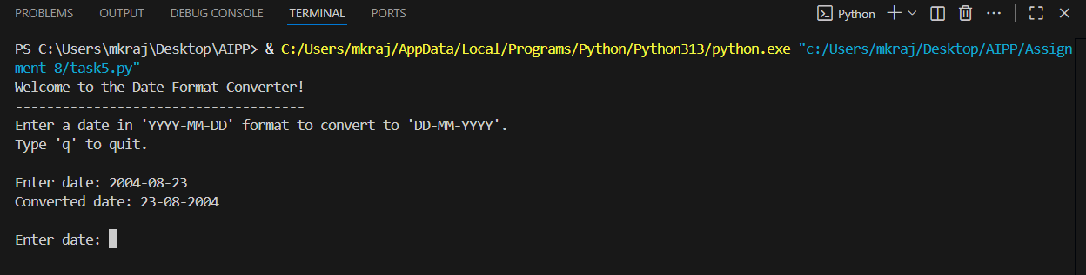  Note: Report should be submitted a word document for all tasks in a single document with prompts, comments & code explanation, and output and if required, screenshots |  |  |  |  |  | qw

